[https://www.udemy.com/course/complete-machine-learning-and-data-science-zero-to-mastery](https://www.udemy.com/course/complete-machine-learning-and-data-science-zero-to-mastery/learn/lecture/17654158?start=120)

**What is machine learning?**

Machine learning is a branch of [artificial intelligence (AI)](https://www.ibm.com/cloud/learn/what-is-artificial-intelligence) and computer science which focuses on the use of data and algorithms to imitate the way that humans learn, gradually improving its accuracy.

1. <https://teachablemachine.withgoogle.com/>
2. <https://ml-playground.com/>

Types Of Machine Learning:

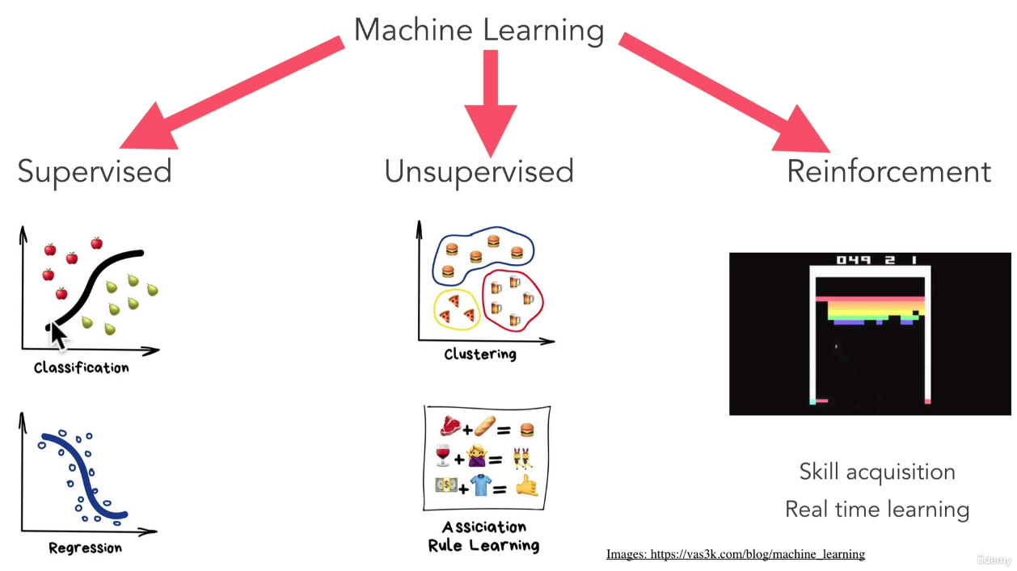

**Learn from data and predict something.**

**Supervised learning, also known as supervised machine learning, is a subcategory of** [**machine learning**](https://www.ibm.com/cloud/learn/machine-learning) **and** [**artificial intelligence**](https://www.ibm.com/cloud/learn/what-is-artificial-intelligence)**. It is defined by its use of labeled datasets to train algorithms to classify data or predict outcomes accurately.**

**Unsupervised learning refers to the use of artificial intelligence (**[**AI**](https://searchenterpriseai.techtarget.com/definition/AI-Artificial-Intelligence)**) algorithms to identify patterns in data sets containing data points that are neither classified nor labeled**

**Reinforcement learning is a machine learning training method based on rewarding desired behaviors and/or punishing undesired ones. In general, a reinforcement learning agent is able to perceive and interpret its environment, take actions and learn through trial and error.**

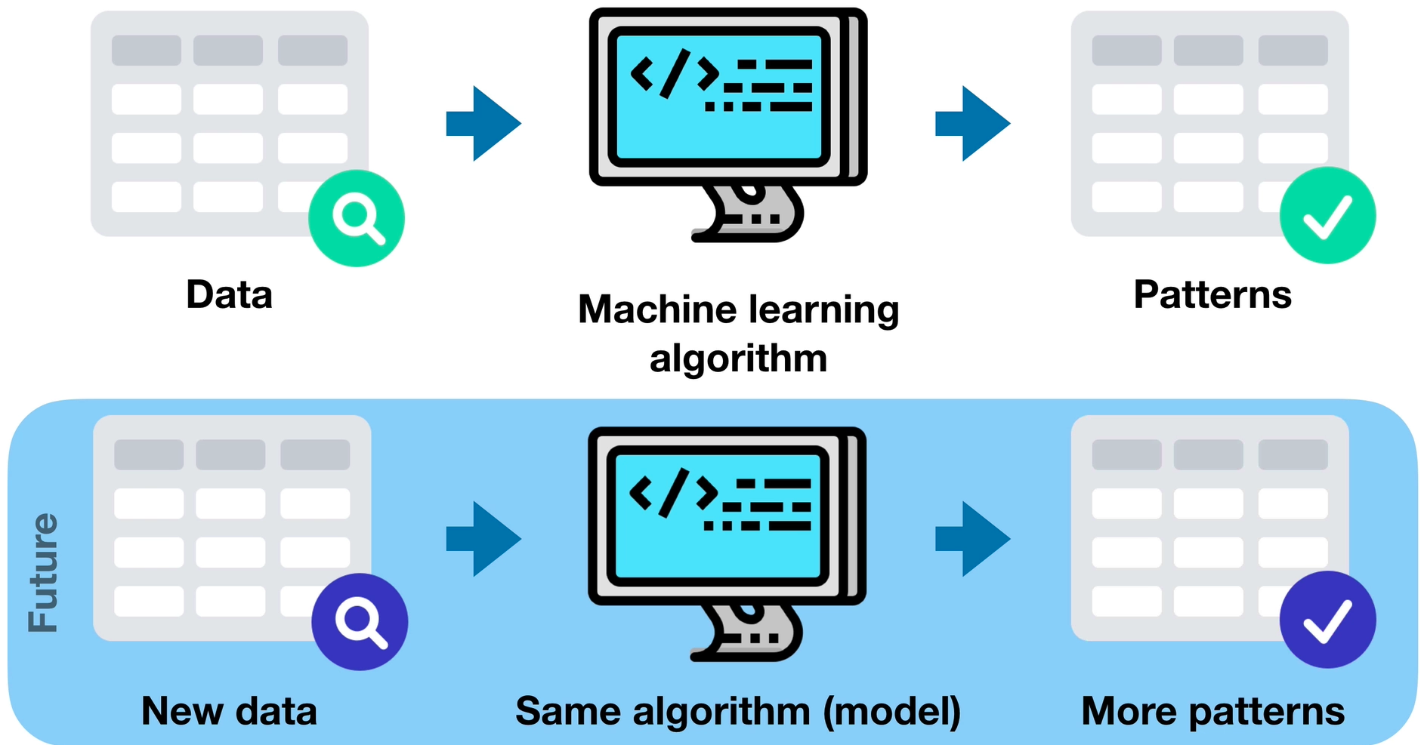

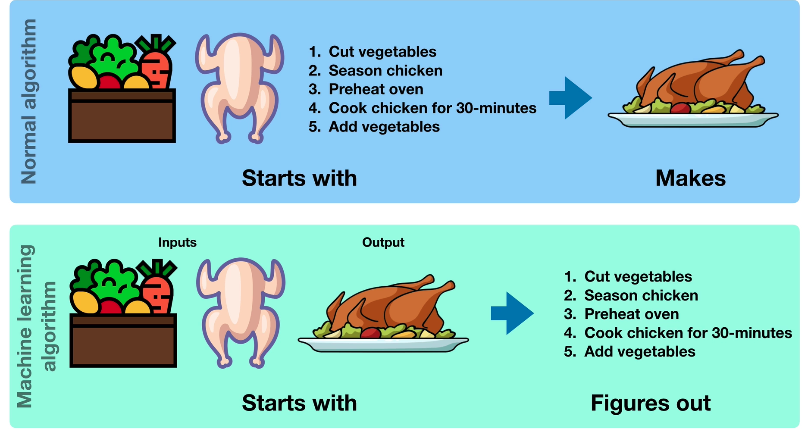

**Building Machine Learning and Data Science Framework:**

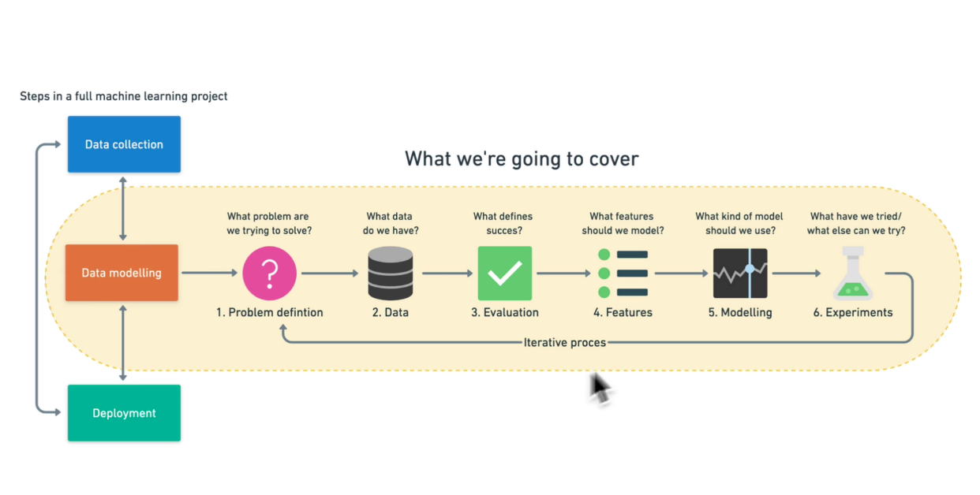

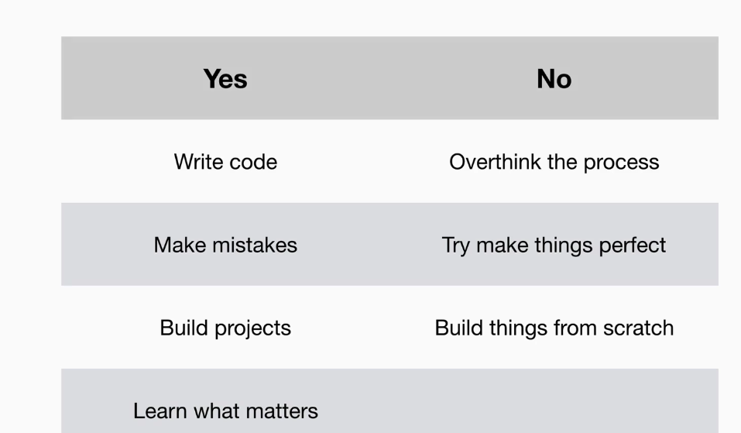

**6 Step Machine Learning Framework:**

Step 1:

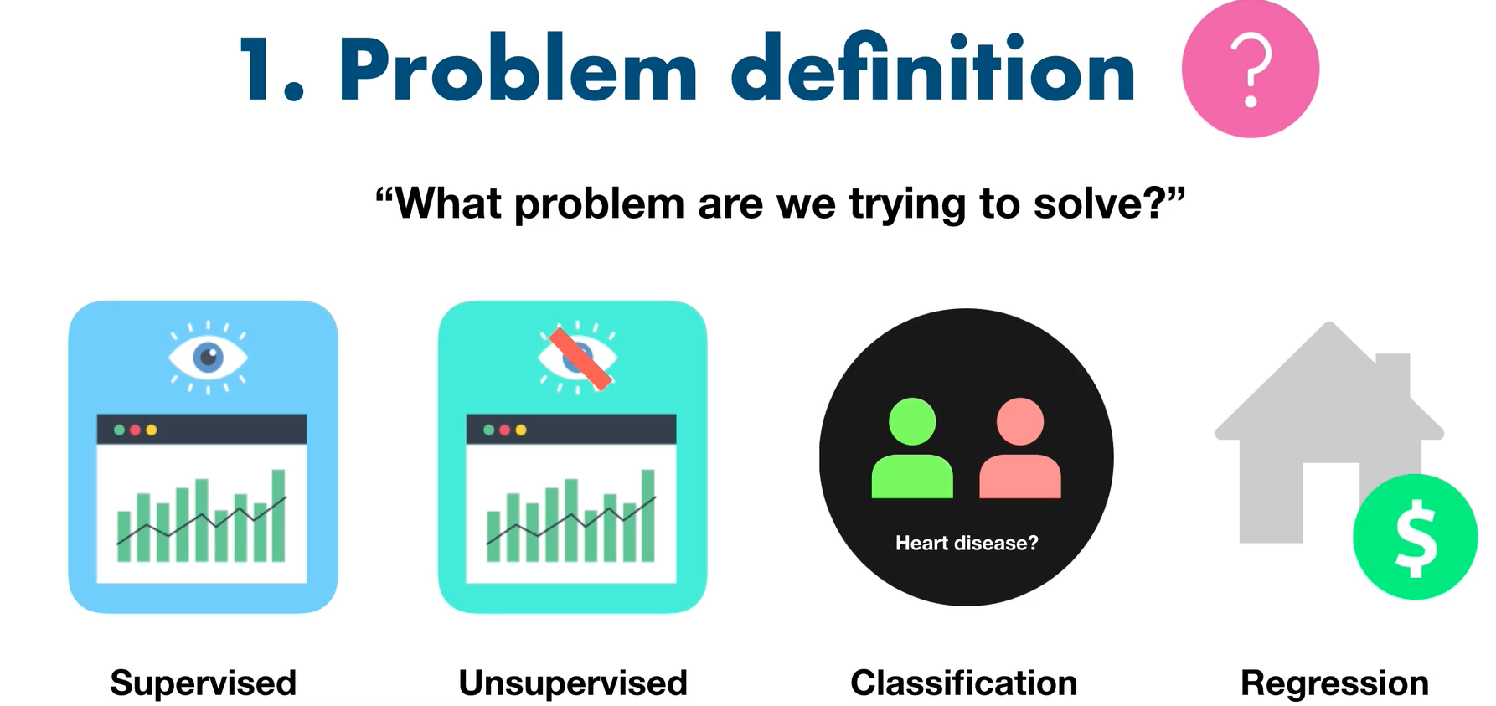

Step 2:

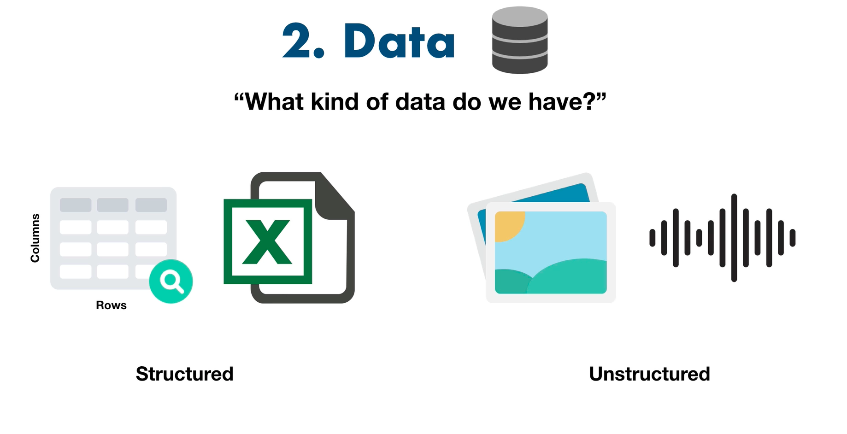

Step 3:

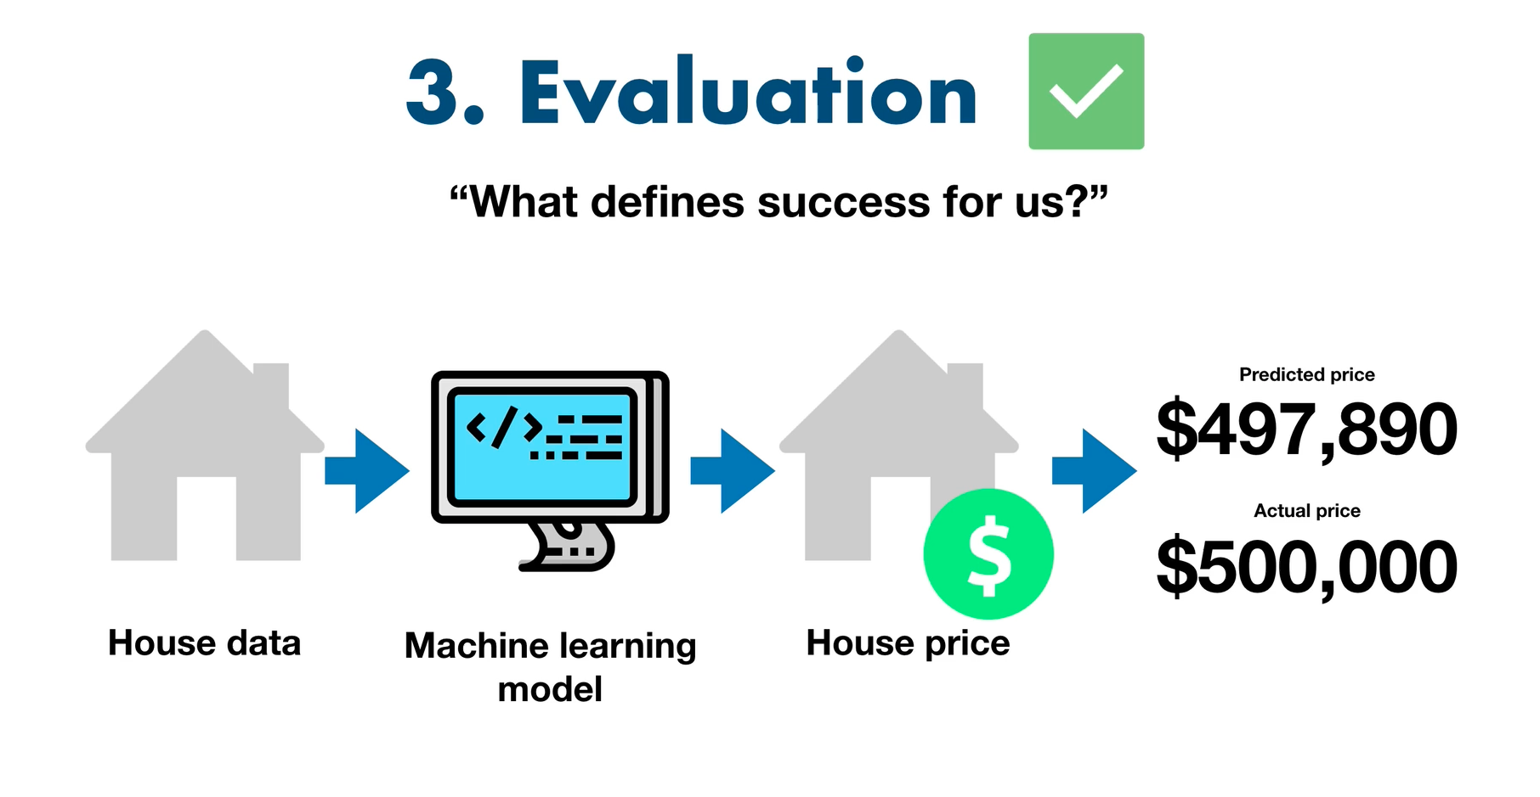

Step 4:

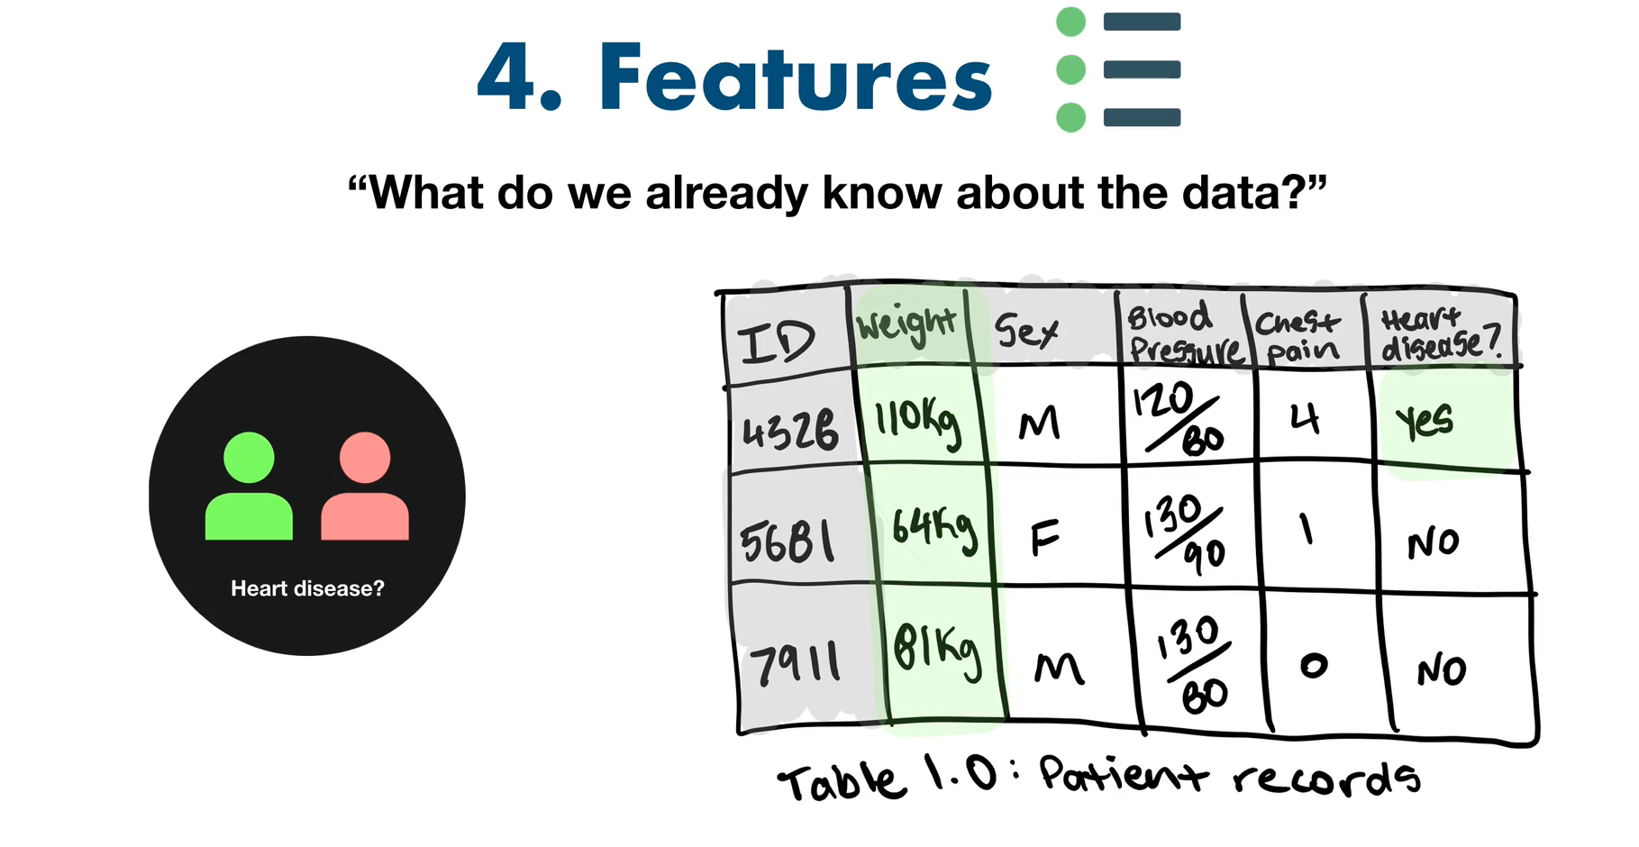

Step 5:

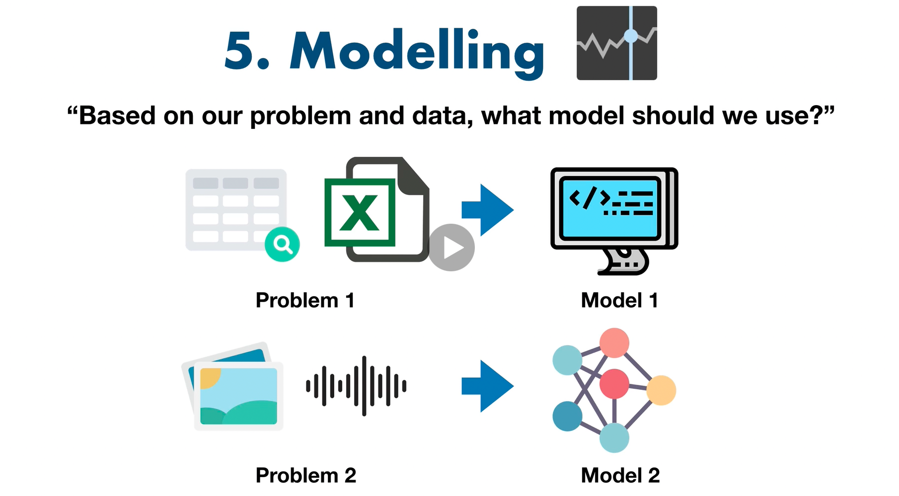

Step 6:

